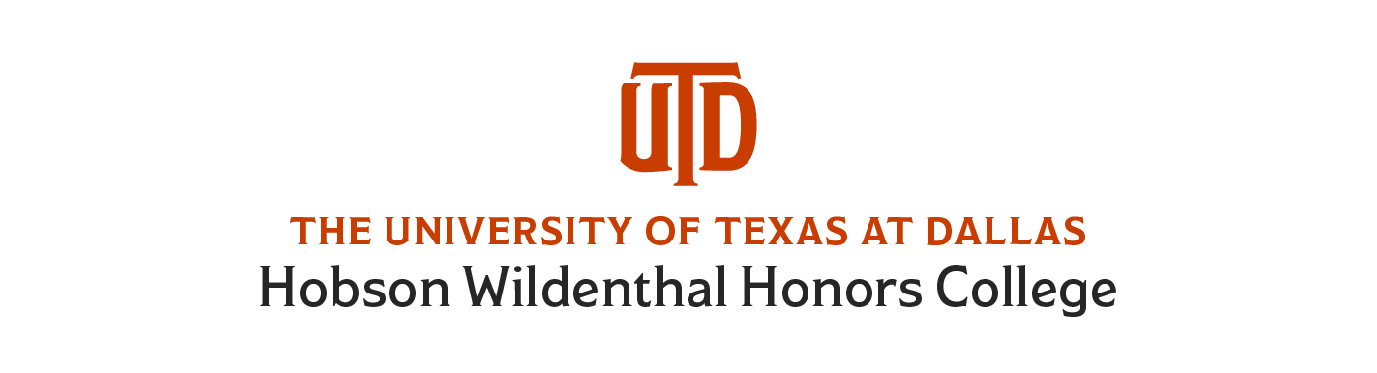
Itinerary
July 1-15, 2018

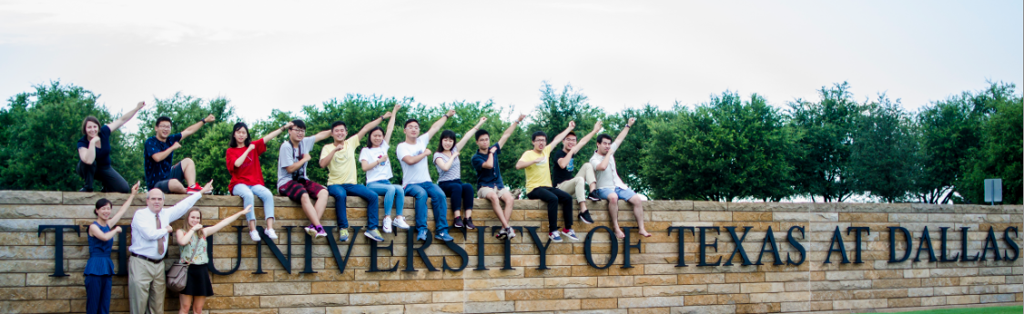
China Exchange Program @ UTD



Important Information

Program Expectations:
- Absolutely no illegal drugs or other restricted substances of any kind allowed in the residence halls, laboratories, or other UTD facilities.
- UTD is a non-smoking campus and there is no smoking allowed by students.
- Student must abide by all other UTD residence policies and procedures as per the housing handbook: http://www.utdallas.edu/housing/handbook/
- Treat peers, staff and all UTD personnel with respect and courtesy.
- Be aware of your surroundings, report inappropriate or suspicious behavior. You have an affirmative responsibility report rule infractions.

Contact Information:
- Dr. Ted Harpham cell: 214-669-1844
- Dr. Eva LaDow cell: 415-244-1126
- Jordan Chen (PA) cell: 469-207-8632
- Cassie Cure cell: 817-602-5311 (from 7/3-7/15)

What is Included:
- Breakfast every morning in the Dining Hall, select number of lunches & dinners in Dining Hall
- Microwave& refrigerator is in your suite in the Residence Hall
- Washer & dryers are available for free in the Residence Hall. We will have laundry detergent available for your use.
- Bedding & towels are included in the Residence Hall
- Free guest WiFi in the Residence Hall
- Access to the Activity Center on campus

What to Bring:
- Sunscreen& bug spray
- Swimsuits (we will have a pool party)& sandals
- Cool, comfortable clothing& walking shoes (it will be hot!)
- Toiletries, feminine hygiene products, if needed
- Umbrella
- Alarm clock (if your cell phone does not have one)
- Camera
- Cell phone/laptop/iPad& charger
- Spending money (not all meals are included, and there are also shopping days)
- If needed: It might get cold indoors, so bring a sweatshirt if you get cold easily

In Case of Emergencies:
- UTDAlert is the UTD automated texting system in case of emergencies. Every subscriber receives a text and instruction in case of any campus related emergency. Text UTDAlert to 888-777 to enroll into the UTDAlert system. If you want to opt-out of the system, text STOP to 888-777. Updates are also available on Twitter or Facebook for UTDAlert messages.
- Campus Status Hotline (972-883-7689) will have updated information on any emergency situations or closings (due to inclement weather).

Campus Map: http://www.utdallas.edu/pdf/campusmap.pdf

ITINERARY
 | Day 1 Sun. 7/1 | Day 2 Mon. 7/2  UTD Welcome Day | Day 3 Tue. 7/3  College Life Day | Day 4 Wed. 7/4  Sports Day/July 4th!
Morning |  | Sleep in!  10:45-12:30: Campus Tour(get a photo with Temoc the mascot!)  (Visitors Center) | 10:00-12:00: Dr. LaDow Presentation on expectations, UTD & Honors College  (Green Center, CV library) | 10:00-12:00:  Frisbee Golf on campus w/PA & language partners (Joey Campain asking for coaches/supplies)
Afternoon & Evening | Late night arrival  Dr. LaDow-meet at airport  PA-meet at Res Hall N | 1:00-3:00: Welcome lunch w/Dr. Harpham & Dr. LaDow  (Green Center atrium/ CV library)  (Qdoba catering)  3:00-5:30: Shopping at w/language partners  (Target)  6:00: Meet at Res Hall to leave for dinner  6:30-8:30: Welcome Dinner-w/Dr. Harpham & Dr. LaDow  (Café Amore) | 12:00-1:30: Lunch  (Jason’s Deli catering)  (Green Center, CV library)  2:00-4:00:Dr. Harpham Presentation on Baseball &Casey at the Bat  (Green Center, CV library)  Dinner in dining hall  Evening: Bowling w/ language partners  (Richardson) | 1:00-3:00: Pool Party w/Dr. LaDow & Dr. Harpham  (Sonny Bryan’s catering)  at Phase 8 Clubhouse  Afternoon-Evening: TexasRangersBaseball Game (vs. Houston Astros) w/PA  (Globe Life Park, Arlington)  4:15: Meet at Res Hall N  4:30: Depart UTD on bus  6:00: Game Time  9:30: Fireworks  10:00: Meet at bus  10:15: Depart  11:15: Arrive at UTD
 | Day 5 Thu. 7/5  Dallas History Day | Day 6 Fri. 7/6  Cooking/Movie Day | Day 7 Sat. 7/7  Cultural Day | Day 8 Sun. 7/8  Shopping Day
Morning | 10:00-11:30: Dr. Harpham presentation on U.S., Texas and Dallas  (Green Center, CV library) | 10:00-12:00: Cooking demonstration/class on brunch foods with Sara Asberry- UTD Nutritionistw/Cassie  (Res Hall N kitchen) | 10:00-12:00: Painting Class  (CV classroom or multipurpose room in Res Hall) | 10:15: Meet in Residence Hall North for Allen Outlet shopping  10:30: Departw/ Tom Lambert’s program
Afternoon & Evening | 11:30-12:00: Lunch  (Chick-fil-A catering)  (Green Center, CV Library)  12:15: Leave for downtown Dallas  1:00-4:00: 6th Floor Museum w/Dr. Harpham  Dealy Plaza  4:00: Head back to campus (dinner in dining hall) | 12:30-1:30: Lunch—dining hall  2:00-5:00:Film& discussion w/Dr. Dow—The Searchers(AD 2.238, CV classroom)  Dinner:walk to Northside (several options)  8:00: Board Game Night w/Clark Scholars  (Green Center, CV Lounge) | 12:30-1:00:  Leave for shopping near Alamo Drafthouse  Evening: Movie & dinner at Alamo Drafthouse (Richardson) | 4:30: Make final purchase  Evening: Dinner at Jordan Chen (PA)’s family’s home
 | Day 9 Monday 7/9  Science/Engr. Day | Day 10 Tuesday 7/10  Arts & Science Day | Day 11 Wed. 7/11  UTSW Day | Day 12 Thu. 7/12  Ft. Worth Day
Morning | 10:00-11:00: Tour of Biomedical Engineering labs (w/ Shane Solis, Director of Lab Safety and w/Dr. LaDow)  (meet in RL lobby; end in BSB lobby) | 9:30: Meet at Res Hall South lobby to leave for downtown Dallas (w/Wendi &Dr. Harpham)  11:00-1:00: Tour of DMA(w/Wendi) | 10:00-1:00:UTSW International Education, reception& lunch w/Chinese postdoctoral Fellows (Stu Ravnik) w/Dr. LaDow | 9:30: leave for Ft. Worth w/Cassie & Dr. Harpham  (bus picking up in Green Center lot)  10:30: Arrive at Stockyards Station  11:30: Cattle Drive
Afternoon & Evening | 11:30-12:30: Dr. LaDow presentation on Neuroscience  12:30-1:30: Lunch (Little Greek Fresh Grill catering)  1:30-3:00:Dr. Harpham-Introduction to arts and science day  (Green Center, CV Library)  Dinnerin dining hall  7:00: Movie Night w/Clark Scholars | 1:00-2:00: Lunch atDMA Cafe(pay on their own)  2:00-Nasher Sculpture Garden w/Dr. LaDow  3:00-5:00: Perot Museum w/Dr. LaDow  6:00:dinner at El Fenix | 2:00-5:00:Film & discussion w/Dr. Dow(film TBD)  (AD 2.238, CV Classroom)  Dinner in dining hall or walk to Northside | 12:00-1:15: Lunch at Stockyards Station (Risky’s BBQ)  1:30: get back on bus to get to museums  2:00-5:00:Museum visits-Amon Carter, Kimball, Modern  5:00:Back on bus to campus for dinner
 | Day 13 Fri. 7/13  Presentation Day | Day 14 Sat. 7/14  Free Day | Day 15 Sun. 7/15  Farewell!
Morning | 10:00-11:30: Presentation Prepw/Drs. Harpham & Dr. LaDow  (Green Center, CV Library) | Free Time w/language partners:  -Dallas Arboretum (if not too hot)  -North Park Mall (for something indoors) | 5:00: Depart from dorms  8:00: flight from DFW Airport
Afternoon & Evening | 12:00-1:30:Lunch  (Green Center, CV Library)  (La Madeline catering)  2:00-4:00: Student powerpoint presentations w/Dr. LaDow & Dr. Harpham  (AD 2.238, CV classroom)  6:00: Dinner at Twisted Root Burger Co. | Afternoon: Roundtable w/current Honors students  Free Evening

Roommates in Res Hall N(10 China students; 1 China staff; 1 PA)
5 suites
Name (Roommate #1) | Name (Roommate #2) | Name (Roommate #3)
1 Ma, Haoyan (M)  Sophomore-Electrical Engineering | 1 Wang, Yang (M)  Sophomore-Electrical Engineering | 1 Sun, Haoyu (M)  Sophomore-Electrical Engineering
2 Dong, Yong (M)  Sophomore-Electrical Engineering | 2 Wu, Chaoyi (M)  Sophomore-Electrical Engineering | 2 Lyu, Jiaxin (M)  Sophomore-Electrical Engineering
3 Luo, Yifan (M)  Sophomore-Electrical Engineering | 3 Li, Yang (M)  Sophomore-Electrical Engineering | 3 Wang, Weitao (M)  Freshman-undecided
4 Chen, Yuhe (F)  Freshman-undecided | 4Chen, Jordan (F) –PA  Junior-Biology
Name (Single room)
5Li, Xin (F)
Staff

